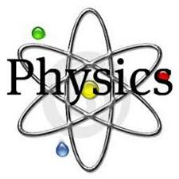

Physics A LEVEL
Course handbook &
Pre course tasks
2023/2024
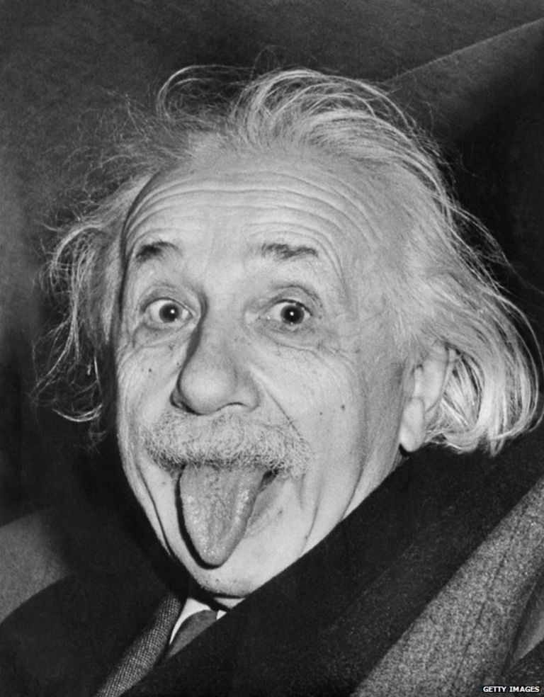

Course outline with key assessments

The specification can be accessed here(OCR Specification) and it is strongly advisable to have a copy to refer to in addition to your checklists:

http://www.ocr.org.uk/qualifications/as-a-level-gce-physics-a-h156-h556-from-2015/

The course is split into distinct areas with different teachers taking responsibility for certain parts of the modules as outlined in the table below.

HOW THE COURSE IS DELIVERED

The course is delivered in laboratories, typically by 2 specialist members of teaching staff, sharing the course content and practical skills in proportion to teaching. The course is broken into 6 Modules with subsidiary units, most of which have a mathematical requirement which varies from unit to unit. Key mathematical skills learned in GCSE are expected to be fluidly applied with some natural extension of skills.

Practical work is assessed as shown below in a stand-alone qualification where the emphasis is on building practical skills of executing and recording work with an examined content in the exams at the end of the course. In lessons students will be either working individually, in pairs and in groups for both practical and theoretical tasks.

The Assessment Objectives, as at GCSE, are split into 3 areas:

AO1: Demonstrate knowledge and understanding of scientific ideas, processes, techniques and procedures.
AO2: Apply knowledge and understanding of scientific ideas, processes, techniques and procedures:
- in a theoretical context
- in a practical context
- when handling qualitative data
- when handling quantitative data.

AO3: Analyse, interpret and evaluate scientific information, ideas and evidence, including in relation to issues, to:
- make judgements and reach conclusions
- develop and refine practical design and procedures.
These are allocated 31-34%, 40-43% and 25-28% of the overall marks in the A Level examinations respectively.

Integrated in the course are revision, consolidation, extension and regular testing lessons. Personalised Learning Checklists (PLCs) with links to the A Level Physics Specification should be reflected upon to gauge progress and feed forward. As the theoretical content of the course is fully examined a lot of emphasis is put on Exam Style questions where students work through previous exam questions and develop effective exam technique.

The use of links to university and industry is being constantly re-assessed and a range of experiences are fitted in to the course to complement and highlight different avenues available. Headstart courses, Gold CREST awards and Year in Industry are all extra-curricular activities students can access as well as school organised activities.
Course Text books: Students will have access to an E-Book via KERBOODLE which not only allows access on many platforms but contains a range of revision resources and questions and extension task to assist learning beyond reviewing the course content. There are also books which may be used in school but not taken away.
The paperback version of the text books are:

Title | ISBN | Price on Amazon
A level Physics for OCR Year 1 & AS | ISBN-13: 978-0198352174 | £25.77
A level Physics for OCR Year 2 | ISBN-13: 978-0198357667 | £27.88
A level Physics for OCR (combined for the above) | ISBN-13: 978-0198352181 | £41.99
A level Physics for OCR A Revision Guide | ISBN-13: 978-0198352204 | £14.99
CGP - A Level Physics Exam practice workbook | ISBN-13: 978- 1 78294 925 1 | £10.99
CGP - New A-Level Physics: OCR A Year 1 & 2 Complete Revision & Practice with Online Edition (CGP A-Level Physics) | ISBN-13: 978-1789080391 | £14.98
CGP Essential Maths Skills for A-Level Physics | ISBN-13: 978-1782944713 | £7.33
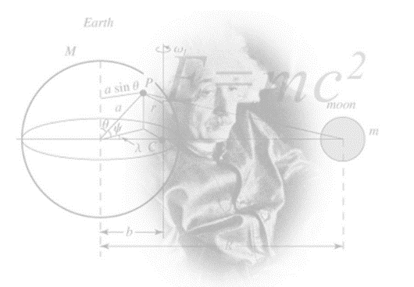

Overview of A Level in Physics A (H556)
Content Overview | Assessment Overview
Content is split into six teaching modules:  - Module 1 – Development of practical skills in physics  - Module 2 – Foundations of physics  - Module 3 – Forces and motion  - Module 4 – Electrons, waves and photons  - Module 5 – Newtonian world and astrophysics  - Module 6 – Particles and medical physics | Modelling physics (01) 100 marks 2 hours 15 minutes written paper assesses content from modules 1, 2, 3 and 5. | 37%  of total A level
 | Exploring physics (02) 100 marks 2 hours 15 minutes written paper  assesses content from modules 1, 2, 4 and 6. | 37%  of total A level
 | Unified physics (03) 70 marks 1 hour 30 minutes written paper assesses content from all modules (1 to 6). | 26%  of total A level
 | Practical endorsement in physics (04)* (non-exam assessment) | Reported separately (see Section 5h)

A LEVEL PHYSICS DEPARTMENTAL EXPECTATIONS

- Students are expected to purchase a working file in order to record and organise any notes and worksheets used in lessons.
- Students are expected to have the correct stationary for the lessons including pens, pencils, SCIENTIFIC CALCULATOR, scissors, glue and highlighters.
- Students are expected to attend all lessons.
- As the lessons involve a lot of theoretical and practical work and Exam Style Questions being used at home and in lessons, it is expected that students will complete all home study tasks to a high standard and these must be handed in on time.
- Students should be aiming to read around the subject and further their knowledge of Physics applications or theories beyond the curriculum.
- MISSED LESSON CONTENT DUE TO ABSENCE – Students are expected to catch up in their designated study periods (work is shown to teacher upon arrival to the next lesson)
- ONE GRADE BELOW TARGET IN ANY ASSESSMENT/HSTUDY – Student produces some revision or review work to assist understanding
- POOR QUALITY OF HOME STUDY – This will not be accepted and a PHYSICS supported study will be triggered
- Students are expected to pre-read the PAG method sheet and write up practical work and submit for marking according to the PAG criteria sheet stuck in with the practical

HOME STUDY STRUCTURE

For every hour of lesson, it is expected students dedicate an hour to independent study time. Home study will be set using the following sections:

Gaps to close – You act upon feedback, close the gaps in your learning e.g. writing a summary, re-answering test questions underperformed in, producing a glossary of key terms, mark scheme mnemonics, re-reading and extending lesson notes, practice testing, creating a model answer or mark scheme for areas struggling in, address PLC gaps etc.
Revision – Creating revision resources based upon what was taught in the lesson. E.g. Mind Map, Flash Card, lists, learning key word definitions.
Assessed Designated Study Tasks – Teacher set tasks which will be self/peer/teacher assessed depending upon what the teacher directs. These tasks are to be completed in Designated Study time and reflected upon in DIRT/ Starter Tasks once the deadline has passed. This could also include a flipped learning task (See P below)
Support – Identify areas from PLCs that may need teacher/peer support or extension after strategies have been tried to grasp the content.
Please take responsibility for making sure you ask for help if it is needed.
Pre-work - flipped learning – research undertaken ready for the next lessons content or extension work
EXAMINATION PERIODS

- Initial assessment in the first few weeks to allow students an insight into their suitability
- Internal progress check tests are integrated during the course, alongside homestudy and mock examinations
- Internal examination in March/April with additional testing/resits after half term to assist in UCAS applications
- Practical Assessment – on-going during the course to be written up and submitted as instructed (normally within a week)
- Examinations – May/June of Year 13

PRE COURSE START UP TASKS

Please make sure that you have prepared the following before lesson 1 begins.

TASK 1: Course File
Please buy one A4 leaver arch file with file dividers to allow the notes to be broken down and organised. Your surname, ‘A Level PHYSICS’ should be on the folder. The data booklet and pre-course booklet should be in your folder for reference.
Please ensure you have a scientific calculator, 30cm ruler, pens, pencils, highlighters and an A4 pad of paper.

TASK 2: Pre-Knowledge Tasks

- Complete the Pre Knowledge Tasks on pages 11 to 17
- There will be a baseline test in one of your first lessons so this should help!

TASK 3: Research Task

- Complete an Open University Online Course as outlined on page 18.

For Submission:

- Completed pre-knowledge task from this booklet.
- Completion Certificate from a Physics related OU online course

The following pages have suggestions for books, films and other sources of information that you may like to have a look at.
Below is a selection of books that should appeal to a physicist – someone with an enquiring mind who wants to understand the universe around us.

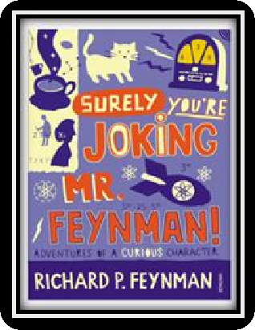
Moondust: In Search of the Men Who Fell to Earth

This book uses the personal accounts of 9 astronauts and many others involved in the space program, looking at the whole space-race era.

Surely You're Joking Mr Feynman: Adventures of a Curious Character

By reading this book you will get insight into his
life’s work including the creation of the first atomic bomb and his work in the field of particle physics.

Quantum Theory Cannot Hurt You: Understanding the Mind-Blowing Building Blocks of the Universe

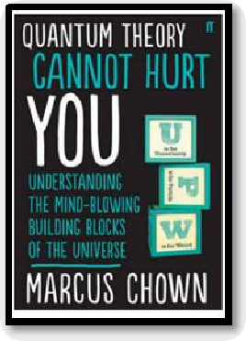
Any physics book by Marcus Chown is an excellent insight into some of the more exotic areas of physics that require no prior knowledge.

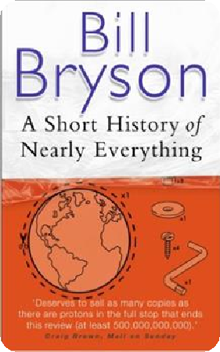
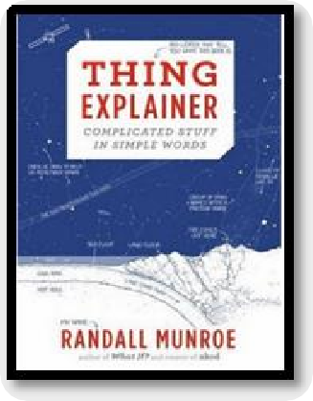
A Short History of Nearly Everything

Thing Explainer: Complicated Stuff in Simple Words

Written by the creator of online comic XTCD (a great source of science humour) is a book of blueprints from everyday objects such as a biro to the Saturn V rocket and an atom bomb.

A whistle-stop tour through many aspects of history from the Big Bang to now. This is a really accessible read that will re- familiarise you with common concepts and introduce you to some of the more colourful characters from the history of science.

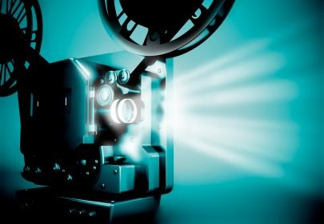

Moon (2009)
Everyone loves a good story and everyone loves some great science. Here are some picks of the best films based on real life scientists and discoveries. You won’t find Jurassic Park on this list! We’ve looked back over the last 30 years to give you our top 5 films you might not have seen before. Great watching for a rainy day.

With only three weeks left in his three year contract, Sam Bell is getting anxious to finally return to Earth. He is the only occupant of a Moon-based manufacturing facility along with his computer and assistant, GERTY. When he has an accident however, he wakens to find that he is not alone.

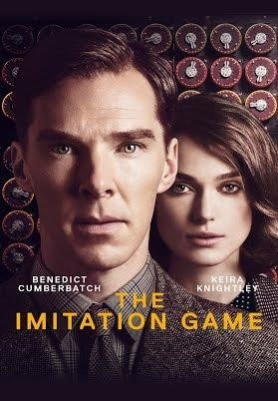
The Imitation Game (2014)
Based on a true story. During World War II, the English mathematical genius Alan Turing tries to crack the German Enigma code with help from fellow mathematicians.

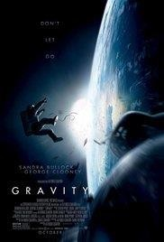

Interstellar (2014)

A team of explorers travel through a wormhole in space in an attempt to ensure humanity's survival.

Gravity (2013)

Two astronauts work together to survive after an accident which leaves them stranded in space.

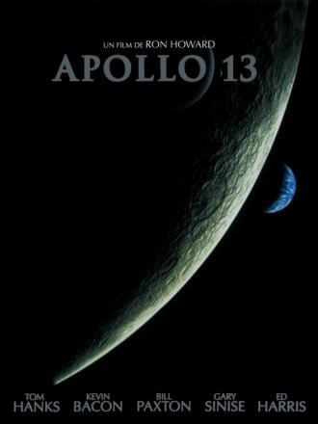
Apollo 13 (1995)

Based on a true story. NASA must devise a strategy to return Apollo 13 to Earth safely after the spacecraft undergoes massive internal damage putting the lives of the three astronauts on board in jeopardy.

There are some great TV series and box sets available too! You might want to check out: Blue Planet, Planet Earth, Wonders of the Universe, Wonders of the Solar System, NASA TV and Shock & Awe – The Story of Electricity.

If you have 30 minutes to spare, here are some great presentations (and free!) from world leading scientists and researchers on a variety of topics. They provide some interesting answers and ask some thought-provoking questions. Use the link or scan the QR code to view:

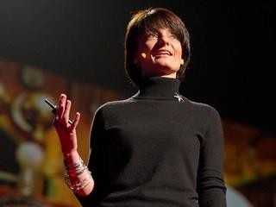
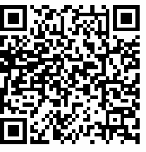
From mach-20 glider to hummingbird drone
Available at: https://www.ted.com/talks/regina_dugan_f rom_mach_20_glider_to_humming_bird_dr one/up-next?language=en
"What would you attempt to do if you knew you could not fail?" asks Regina Dugan, then director of DARPA, the Defense Advanced Research Projects Agency. In this talk, she describes some of the extraordinary projects that her agency has created.

Is our universe the only universe?
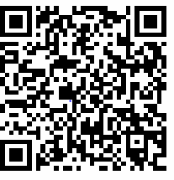
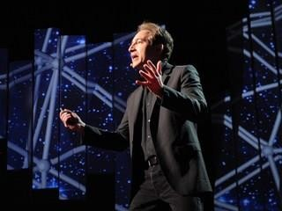
Available at: https://www.ted.com/talks/brian_greene_wh y_is_our_universe_fine_tuned_for_life?langua ge=en
Brian Greene shows how the unanswered questions of physics (starting with a big one: What caused the Big Bang?) have led to the theory that our own universe is just one of many in the "multiverse."

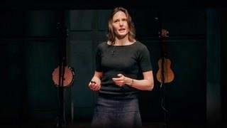
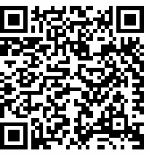
The fascinating physics of everyday life Available at : https://www.ted.com/talks/helen_czerski_ fun_home_experiments_that_teach_you_ physics?language=en
Physicist Helen Czerski presents various concepts in physics you can become familiar with using everyday things found in your kitchen.

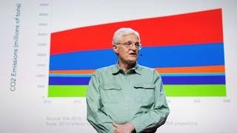
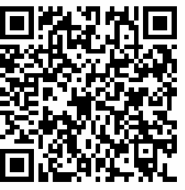
We need nuclear power to solve climate change
Available at : https://www.ted.com/talks/joe_lassiter_we_n eed_nuclear_power_to_solve_climate_chang e?language=en
Joe Lassiter is focused on developing clean, secure and carbon-neutral supplies of reliable, low-cost energy. His analysis of the world's energy realities puts a powerful lens on the touchy issue of nuclear power.

Physics provides daily online-only news and commentary about a selection of papers from the APS journal collection. The website is aimed at the reader who wants to keep up with highlights of physics research with explanations that don’t rely on jargon and technical detail.

For one of the following topics, you are going to use the resources to produce one page of Cornell style notes.

Use the links or scan the QR code to take you to the resources.

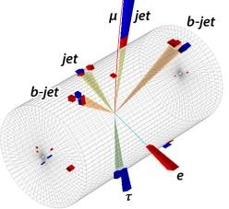
Topic 1: Sizing up the top quarks interaction with the Higgs
Available at: https://physics.aps.org/articles/v11/56 A proton collision experiment at CERN provides a
new handle on the Higgs boson’s interaction with the
heaviest of the quarks.

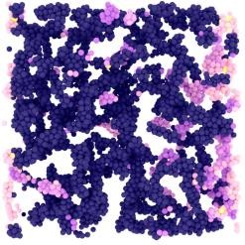
Topic 2: Why soft solids get softer

Available at: https://physics.aps.org/articles/v11/50

Soft materials like gels and creams exhibit fatigue resulting from the stretching of their constituent fibres, according to experiments and simulations.

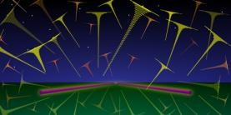
Topic 3: Listening for the cosmic hum of black holes

Available at: https://physics.aps.org/articles/v11/36

A new analysis technique would allow the gravitational-wave “background” from distant black hole mergers to be detected in days instead of years.

A level Physics will use your knowledge from GCSE and build on this to help you understand new and more demanding ideas. Complete the following tasks to make sure your knowledge is up to date and you are ready to start studying:

Symbols and Prefixes

Prefix | Symbol | Power of ten
Nano | n | x 10-9
Micro | μ | x 10-6
Milli | m | x 10-3
Centi | c | x 10-2
Kilo | k | x 103
Mega | M | x 106
Giga | G | x 109

At A level, unlike GCSE, you need to remember all symbols, units and prefixes. Below is a list of quantities you may have already come across and will be using during your A level course.

Quantity | Symbol | Unit
Velocity | v | ms-1
Acceleration | a | ms-2
Time | t | S
Force | F | N
Resistance | R | Ω
Potential difference | V | V
Current | I | A
Energy | E or W | J
Pressure | P | Pa
Momentum | p | kgms-1
Power | P | W
Density | ρ | kgm-3
Charge | Q | C

Task: Solve the following:

- How many metres in 2.4 km?
- How many joules in 8.1 MJ?
- Convert 326 GW into W.

- Convert 54 600 mm into m.
- How many grams in 240 kg?
- Convert 0.18 nm into m.
- Convert 632 nm into m. Express in standard form.
- Convert 1002 mV into V. Express in standard form.
- How many eV in 0.511 MeV? Express in standard form.
- How many m in 11 km? Express in standard form.

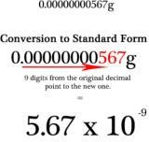
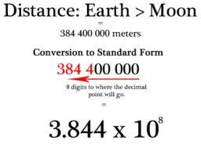
Standard Form

At A level, quantities will be written in standard form and it is expected that your answers will be too.

http://www.ultimatemaths.com/standard-form-conversion.htm

This means answers should be written as ….x 10y. E.g. for an answer of 1200kg we would write 1.2 x 103kg. For more information visit: www.bbc.co.uk/education/guides/zc2hsbk/revision

Task: Complete the following problems;

- Write 2530 in standard form.

- Write 280 in standard form.

- Write 0.77 in standard form.

- Write 0.0091 in standard form.

- Write 1 872 000 in standard form.
- Write 12.2 in standard form.
- Write 2.4 x 10 2 as a normal number.
- Write 3.505 x 10 1 as a normal number.
- Write 8.31 x 10 6 as a normal number.
- Write 6.002 x 10 2 as a normal number.
- Write 1.5 x 10-4 as a normal number.
- Write 4.3 x 103 as a normal number.

Rearranging Formulae

This is something you will have done at GCSE and it is crucial you master it for success at A level. For a recap of GCSE watch the following links:

www.khanacademy.org/math/algebra/one-variable-linear-equations/old-school-equations/v/solving-for-a-variable www.youtube.com/watch?v=_WWgc3ABSj4
Task: Rearrange the following:

- E=m x g x h to find h

- Q= I x t to find I

- E = ½ m v2 to find m
- E = ½ m v2 to find v
- v = u + at to find u
- v = u + at to find a
- v2 = u2 +2as to find s
- v2 = u2 +2as to find u

Significant Figures

At A level you will be expected to use an appropriate number of significant figures in your answers. The number of significant figures you should use is the same as the number of significant figures in the data you are given. You can never be more precise than the data you are given so if that is given to 3 significant your answer should be too. E.g. Distance = 8.24m, time = 1.23s therefore speed = 6.75m/s

The website below summarises the rules and how to round correctly. http://www.purplemath.com/modules/rounding2.htm
Task: Give the following to 3 significant figures:

1. 3.4527
2. 40.691
3. 0.838991
4. 1.0247
Calculate the following to a suitable number of significant figures:

1. 63.2 ÷78.1 =
2. 39 + 78 + 120 =
3. (3.4+3.7+3.2) ÷3 =
4. 0.0256 x 0.129 =

Atomic Structure

You will study nuclear decay in more detail at A level covering the topics of radioactivity and particle physics. In order to explain what happens you need to have a good understanding of the model of the atom. You need to know what the atom is made up of, relative charges and masses and how sub atomic particles are arranged.

The following video explains how the current model was discovered www.youtube.com/watch?v=wzALbzTdnc8

Task: Describe the model used for the structure of an atom including details of the individual particles that make up an atom and the relative charges and masses of these particles. You may wish to include a diagram and explain how this model was discovered by Rutherford.

Recording Data
Whilst carrying out a practical activity you need to write all your raw results into a table. Don’t wait until the end, discard anomalies and then write it up in neat.
Tables should have column heading and units in this format quantity/unit e.g. length /mm
All results in a column should have the same precision and if you have repeated the experiment you should calculate a mean to the same precision as the data.
Below are link to practical handbooks so you can familiarise yourself with expectations.
http://filestore.aqa.org.uk/resources/physics/AQA-7407-7408-PHBK.PDF http://www.ocr.org.uk/Images/295483-practical-skills-handbook.pdf http://www.ocr.org.uk/Images/295483-practical-skills-handbook.pdf
Below is a table of results from an experiment where a ball was rolled down a ramp of different lengths. A ruler and stop clock were used.
Task: Identify the errors the student has made.

 | Time
Length/cm | Trial 1 | Trial 2 | Trial 3 | Mean
10 | 1.45 | 1.48 | 1.46 | 1.463
22 | 2.78 | 2.72 | 2.74 | 2.747
30 | 4.05 | 4.01 | 4.03 | 4.03
41 | 5.46 | 5.47 | 5.46 | 5.463
51 | 7.02 | 6.96 | 6.98 | 6.98
65 | 8.24 | 9.68 | 8.24 | 8.72
70 | 9.01 | 9.02 | 9.0 | 9.01

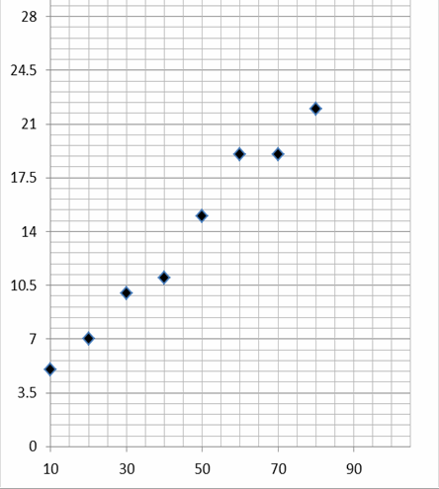
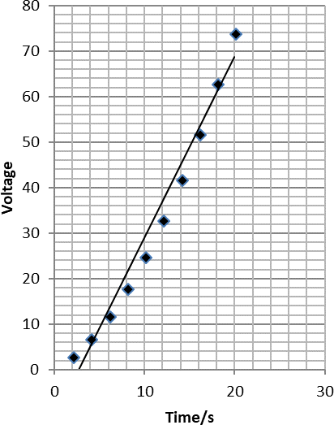

Graphs

After a practical activity the next step is to draw a graph that will be useful to you. Drawing a graph is a skill you should be familiar with already but you need to be extremely vigilant at A level. Before you draw your graph to need to identify a suitable scale to draw taking the following into consideration:

- the maximum and minimum values of each variable
- whether 0.0 should be included as a data point; graphs don’t need to show the origin, a false origin can be used if your data doesn’t start near zero.
- the plots should cover at least half of the grid supplied for the graph.
- the axes should use a sensible scale e.g. multiples of 1,2, 5 etc) Identify how the following graphs could be improved
Graph 1 Graph 2

Forces and Motion

At GCSE you studied forces and motion and at A level you will explore this topic in more detail so it is essential you have a good understanding of the content covered at GCSE. You will be expected to describe, explain and
carry calculations concerning the motion of objects. The websites below cover Newton’s laws of motion and have
links to these in action.

http://www.physicsclassroom.com/Physics-Tutorial/Newton-s-Laws

http://www.sciencechannel.com/games-and-interactives/newtons-laws-of-motion-interactive/

Task: On graph paper sketch a velocity-time graph showing the journey of a skydiver after leaving the plane to reaching the ground. Mark on terminal velocity.

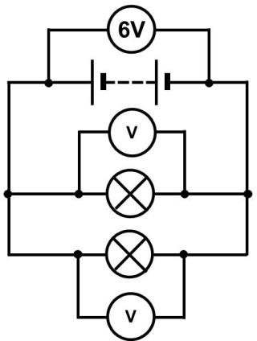
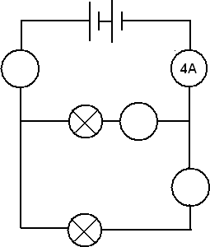
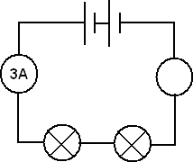
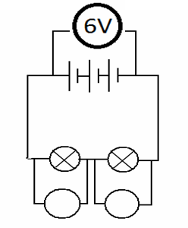
Electricity
At A level you will learn more about how current and voltage behave in different circuits containing different components. You should be familiar with current and voltage rules in a series and parallel circuit as well as calculating the resistance of a device.
http://www.allaboutcircuits.com/textbook/direct-current/chpt-1/electric-circuits/ http://www.physicsclassroom.com/class/circuits

Task:

1a) Add the missing ammeter readings on the circuits below.

b) Explain why the second circuit has more current flowing than the first.

2) Add the missing potential differences to the following circuits

Waves

You have studied different types of waves and used the wave equation to calculate speed, frequency and wavelength. You will also have studied reflection and refraction.

Use the following links to review this topic. http://www.bbc.co.uk/education/clips/zb7gkqt
https://www.khanacademy.org/science/physics/mechanical-waves-and-sound/mechanical- waves/v/introduction-to-waves

https://www.khanacademy.org/science/physics/mechanical-waves-and-sound/mechanical-
waves/v/introduction-to-waves

- Draw a diagram showing the refraction of a wave through a rectangular glass block. Explain why the ray of light takes this path.

- Describe the difference between longitudinal and transverse waves and give an example of each.

- Draw a wave and label the wavelength and amplitude.

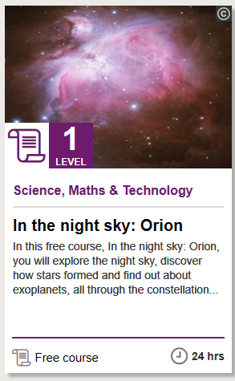
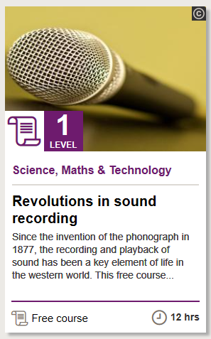
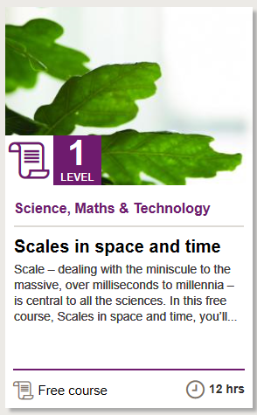
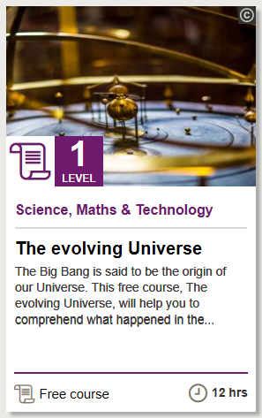
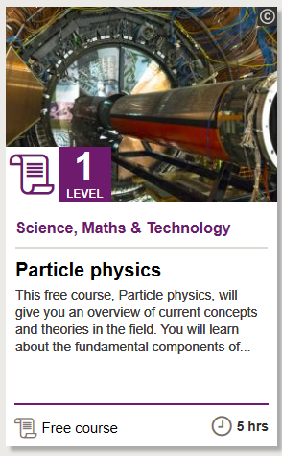
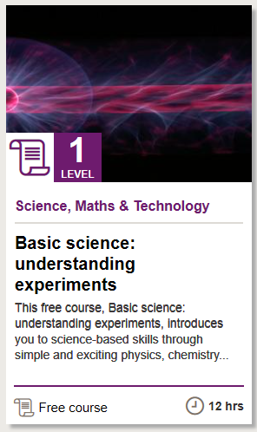
I really wanted to set your research task as something that you could add to your CV that was authenticated by an outside agency so it would be useful to you for future applications. I tried going through all the MOOC options, but found these very awkward to actually find out about and they often involve a fee for certification… then I found this website as part of the Open University…
https://www.open.edu/openlearn/science-maths-technology/free-courses/?filter=date/grid/671,657,655,670/all/all/all/&page=1

They have a massive choice of online courses, all of which are certified, for a range of time lengths. I’ve shown the overview of just a few that are on offer in the science section – so pick a physics topic that you love and dive right in!

You Mission, should you choose to accept it (oh by the way you have to!) is to complete one of these activities and bring in the certificate. The topics below are just for illustration – as long as it’s Physics related, that’s all that matters! This is longer than the prescribed time, but you can use this for your UCAS applications!
Potential Careers
